Azure Cloud Fundamentals and Data Pipeline Implementation using Azure Data Factory

Submitted By
Name: V. Tejasree
The objective of this assignment is to understand Azure cloud fundamentals and implement an end-to-end data pipeline using Azure Storage and Azure Data Factory. The assignment covers resource creation, storage configuration, dataset management, pipeline development, pipeline execution, and IAM role assignments.
Task 1:
Explore Azure Portal
Create a Resource Group
- I logged in to the Microsoft Azure Portal using my Azure account.
- After signing in, I used the search bar at the top of the portal and searched for Resource Groups.
- From the search results, I opened the Resource Groups service.
- I clicked the + Create button to create a new Resource Group.
- On the Basics page, I selected my subscription as Azure for Students.
- In the Resource Group Name field, I entered celebal-adf-rg.
- I selected Central India as the region for the Resource Group.
- After entering the required details, I clicked Review+ Create.
- I carefully reviewed the subscription, resource group name, and region details displayed on the review page.
- Once the validation was successful, I clicked Create to deploy the Resource Group.
- Azure started the deployment process and I waited for it to complete.
- After receiving the successful deployment notification, I opened the newly created Resource Group to verify that it had been created successfully.
- I captured the screenshot of the Resource Group details page as evidence for the assignment submission.
Deliverable:Screenshot of Resource Group
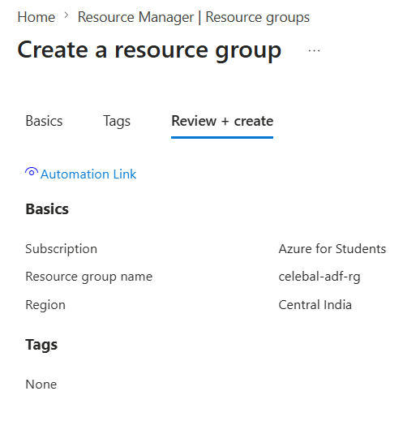
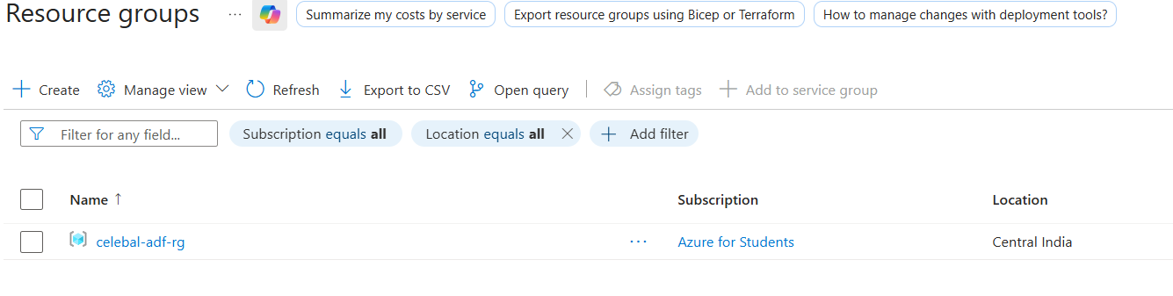

Task 2: Storage Setup
Do:
- Create a Storage Account
- Create a Blob Container
- Upload a CSV file

- Steps Performed for creaying storage account
- Logged in to the Microsoft Azure Portal.
- Searched for Storage Accounts using the search bar.
- Opened the Storage Accounts service and clicked Create.
- Selected Azure for Students as the subscription.
- Chose celebal-adf-rg as the Resource Group.
- Entered a unique Storage Account name ie celebalstorage1234
- Selected Central India as the region.
- Kept Performance as Standard.
- Selected Locally-redundant Storage (LRS) as the redundancy optio
- Left the remaining settings as default.
- Clicked Review + Create and verified the configuration.
- Clicked Create to start the deployment.
- Waited for the deployment to complete successfully
- Verified the Storage Account creation and captured the screenshot.

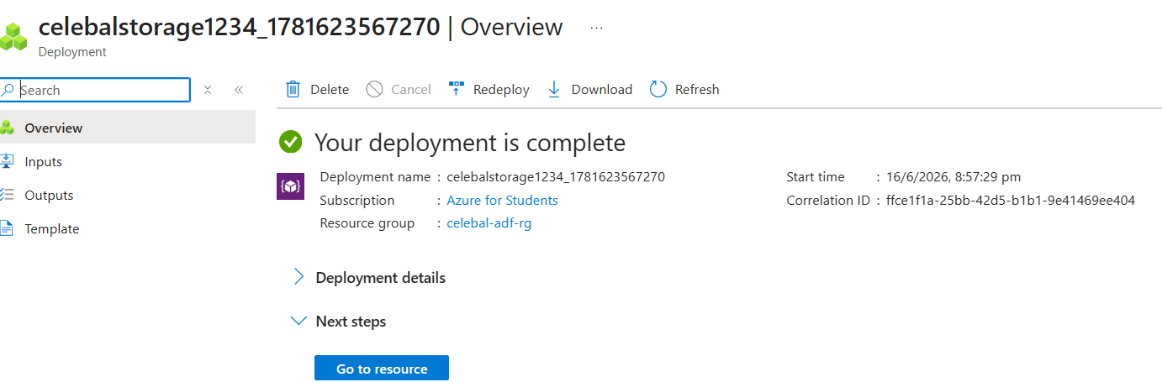

- Steps Performed for creating blob containers
- Opened the Storage Account created in the previous step.
- Navigted to the Containers option under the Data Storage section.
- Clicked on Add Container.
- Entered source-container as the container name.
- Selected Private as the access level.
- Clicked Create to create the source container.
- Clicked Add Container again.
- Entered destination-container as the container name.
- Selected Private as the access level.
- Clicked Create to create the destination container.
- Verified that both containers were successfully created in the Storage Account.
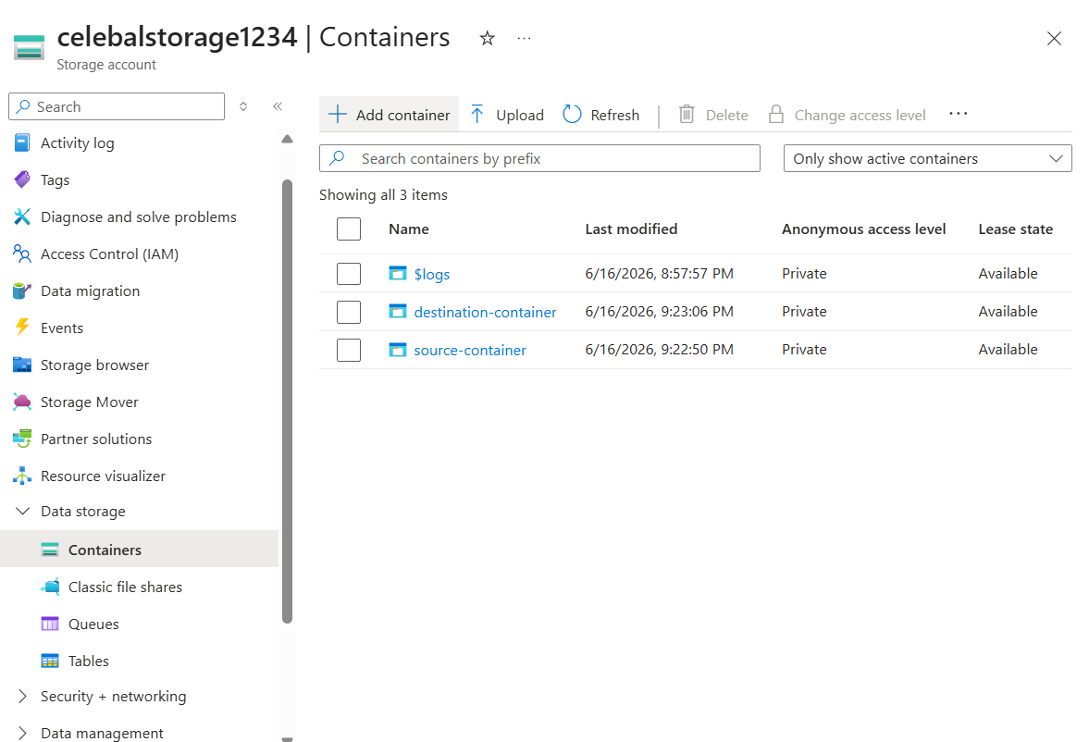
- Steps Performed for uloading csv
- Opened the source-container from the Storage Account.
- Clicked on the Upload button available at the top of the page.
- Clicked the folder icon and selected the Sample - Superstore.csv file from my local system.
- Kept all other upload settings at their default values.
- Clicked Upload to upload the CSV file to the container.
- Waited for the upload process to complete successfully.
- Verified thathe CSV file appeared in the container with its size and last modified date.
- Captured the screenshot showing the uploaded file inside the source container.

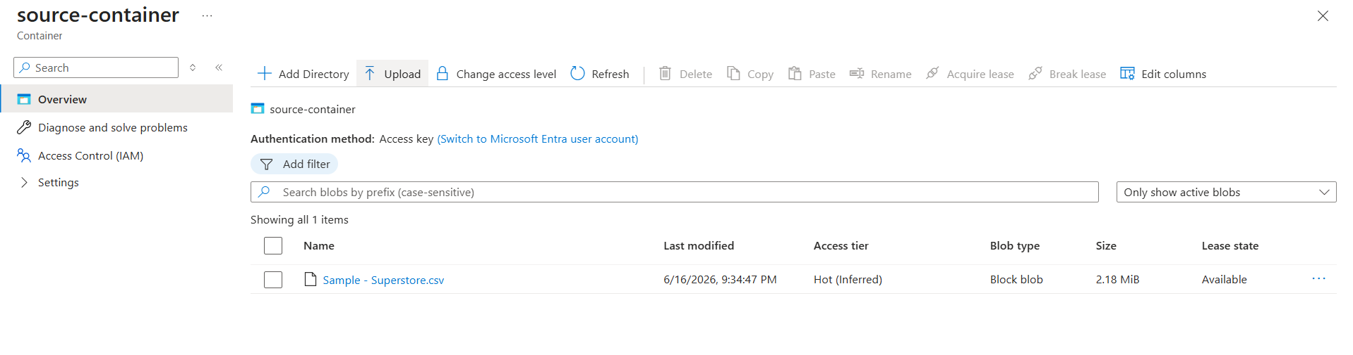
Task 3: ADF Basics
- Create Azure Data Factory
- Explore ADF UI (Author, Monitor, Manage)
- Create Linked Service (Blob Storage)
- Create datasets (source + destination)
- Use Get Metadata activity
Deliverable:
Screenshot of Linked Service
Screenshot of dataset
Screenshot of Get Metadata activity
- Steps Performed for Create Azure Data Factory
- Searched for Data Factories in Azure Portal.
- Clicked Create.
- Selected Azure for Students subscription.
- Chose celebal-adf-rg as the Resource Group.
- Entered a unique Data Factory name.
- Selected Central India as the region.
- Kept the version as V2
- Clicked Review + Create.
- Verified the details and clicked Create.
- Waited for the deployment to complete successfully
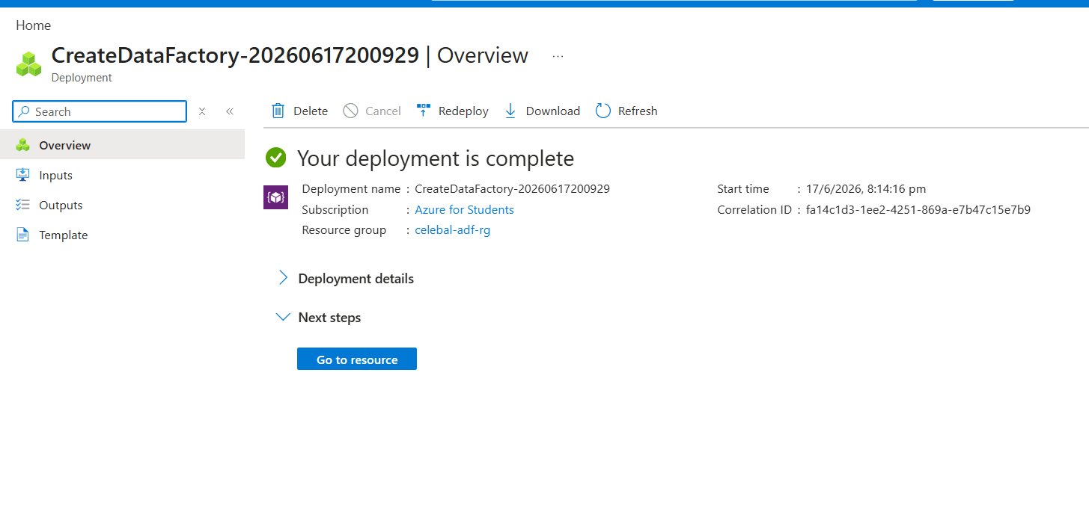
- Steps Performed Explore ADF UI (Author, Monitor, Manage)
- Opened the created Azure Data Factory resource.
- Clicked Launch Studio to open ADF Studio
- Explored the Author section to view pipelines, datasets, and linked services.
- Explored the Monitor section to view pipeline execution and monitoring options.
- Explored the Manage section to view linked services, integration runtimes, and triggers.
- Familiarized myself with the ADF Studio interface and its main features.
- Steps Performed Create Linked Service (Blob Storage)
- Opened the created Azure Data Factory and launched ADF Studio.
- Navigated to the Manage section from the left sidebar.
- Selected Linked Services under the Connections category.
- Clicked + New to create a new linked service.
- Searched for Azure Blob Storage and selected it.
- Entered AzureBlobStorage1 as the Linked Service name.
- Selected Account Key as the authentication method.
- Chose From Azure Subscription as the account selection method.
- Selected the Azure for Students subscription.
- Chose the previously created Storage Account.
- Clicked Test Connection and verified that the connection was successful.
- Clicked Create to save the Linked Service.
- Verified that the Linked Service was created successfully.
Screenshot of Linked Service
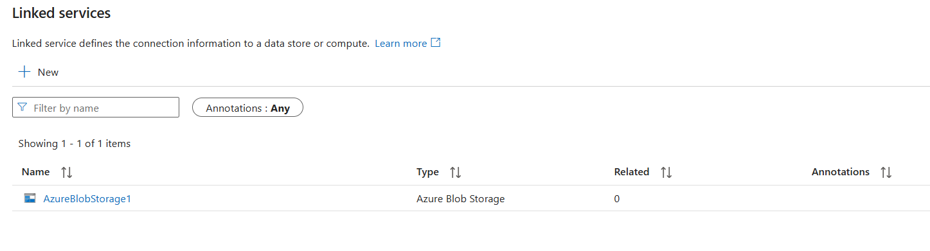
- Steps Performed Create datasets (source + destination)
- Opened the Author section in ADF Studio.
- Clicked the + icon next to Datasets and selected New Dataset.
- Selected Azure Blob Storage as the data store.
- Chose DelimitedText (CSV) as the file format.
- Entered SourceSuperstoreCSV as the dataset name.
- Selected the previously created Azure Blob Storage Linked Service.
- Configured the file path by selecting source-container and choosing the uploaded Sample - Superstore.csv file.
- Enabled the First row as header option.
- Selected Import schema from connection/store.
- Clicked OK to create the dataset.
- Opened the Preview Data tab and verified that the Superstore dataset records were displayed correctly.
- Clicked Publish All and published the changes successfully.
Screenshot of dataset
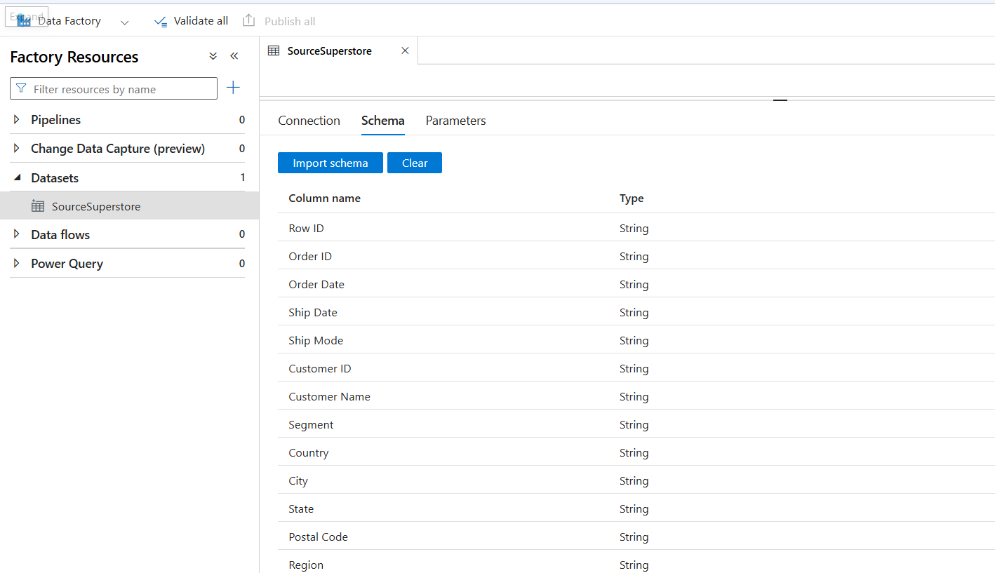
- Steps Performed for Use Get Metadata activity
- Opened the Author section in ADF Studio.
- Clicked the + icon next to Pipelines and selected New Pipeline.
- Entered SuperstorePipeline as the pipeline name.
- Expanded the General category from the Activities panel.
- Dragged the Get Metadata activity onto the pipeline canvas.
- Selected the activity and renamed it to GetSourceMetadata.
- Opened the Settings tab of the activity.
- Selected SourceSuperstore as the dataset.
- Added the required field items: exists, size, columnCount, and structure.
- Verified the activity configuration.
- Clicked Publish All and published the changes successfully.

Screenshot of Get Metadata activity
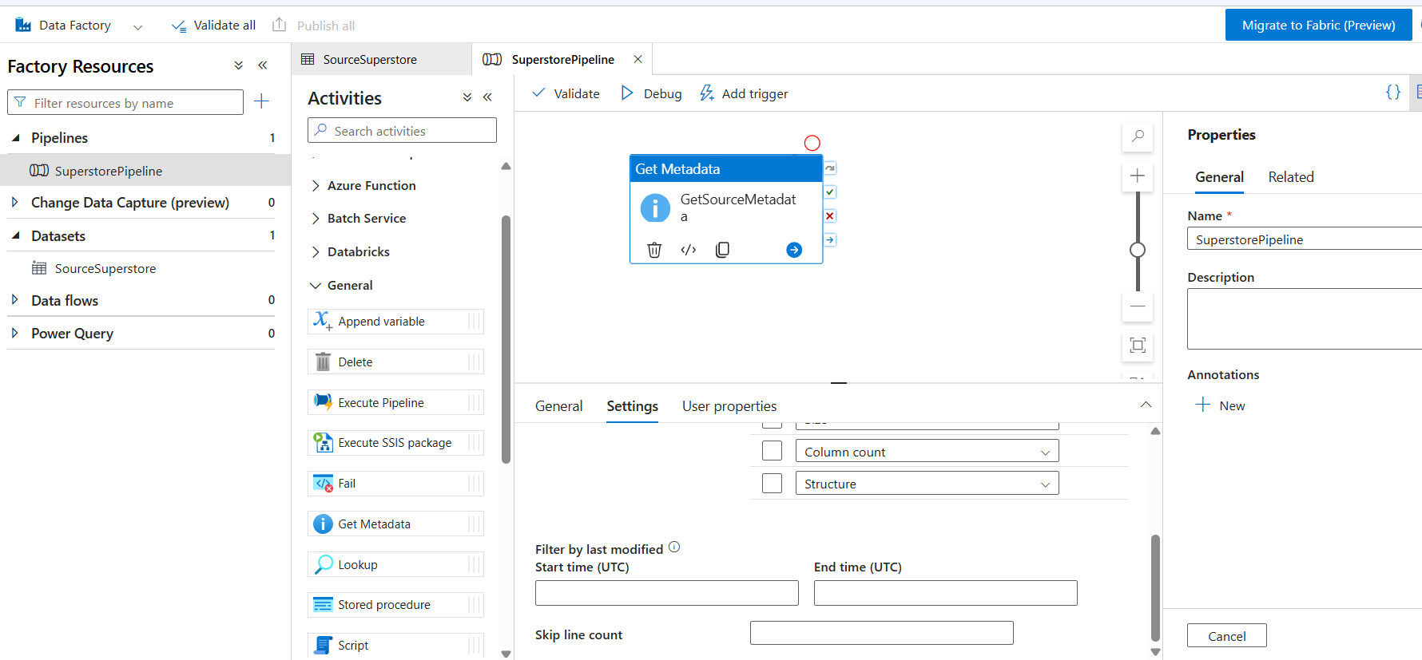

Task 4: Pipeline Development
Do:
- Create pipeline using Copy Data activity
- Configure source and destination
- Add ForEach activity (optional if multiple files)
Deliverable:
Screenshot of pipeline design

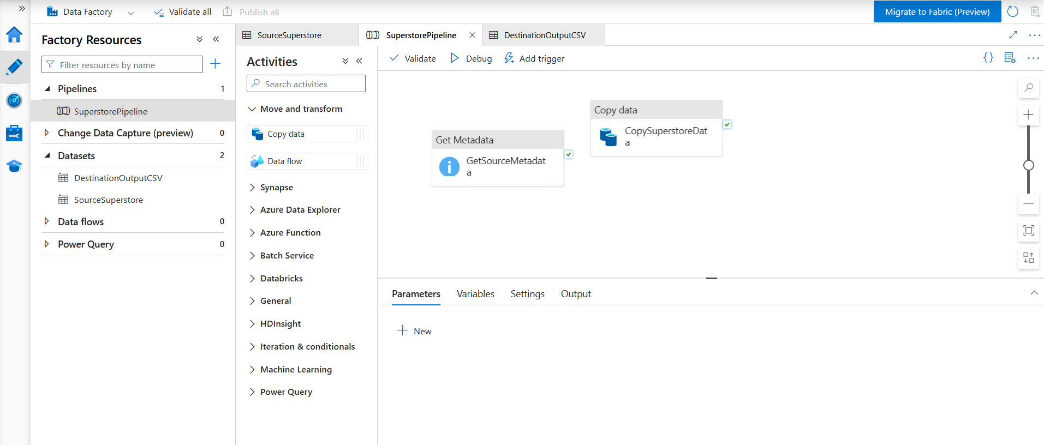
- Steps Performed for Pipeline Development
- Opened the SuperstorePipeline in Azure Data Factory Studio.
- Created a destination dataset named DestinationOutputCSV and configured it to write data into the destination-container.
- Published the newly created destination dataset.
- Opened the SuperstorePipeline and added a Copy Data activity from the Move and Transform section.
- Connected the GetSourceMetadata activity to the CopySuperstoreData activity using the success dependency.
- Selected the CopySuperstoreData activity and configured the source settings.
- Selected SourceSuperstore as the source dataset.
- Configured the sink settings by selecting DestinationOutputCSV as the destination dataset.
- Verified the pipeline configuration and activity connections.
- Clicked Validate All to validate the pipeline.
- Clicked Publish All and published the pipeline successfully.

Task 5: Pipeline Execution
Do:
Run pipeline using Debug/Trigger
Deliverable:
Screenshot showing pipeline execution (Succeeded)

Steps Performed foe running pipeline using debugger
- Opened the SuperstorePipeline in Azure Data Factory Studio.
- Clicked the Debug option available in the top toolbar to execute the pipeline.
- Waited for the pipeline execution to start and monitored the run status in the Output panel.
- Observed the GetSourceMetadata activity running first and successfully retrieving metadata from the source CSV file.
- Verified that the status of GetSourceMetadata changed from Queued to In Progress and finally to Succeeded.
- Observed the CopySuperstoreData activity executing after the successful completion of the metadata activity.
- Verified that the status of CopySuperstoreData changed from Queued to In Progress and finally to Succeeded.
- Confirmed that both activities displayed a green check mark indicating successful execution.
- Verified that the overall pipeline status was displayed as Succeeded in the Output section.
- Navigated to the Azure Portal and opened the Storage Account celebalstorage1234.
- Opened Containers and selected destination-container.
- Verified that the output file output.csv was successfully created in the destination container after pipeline execution.

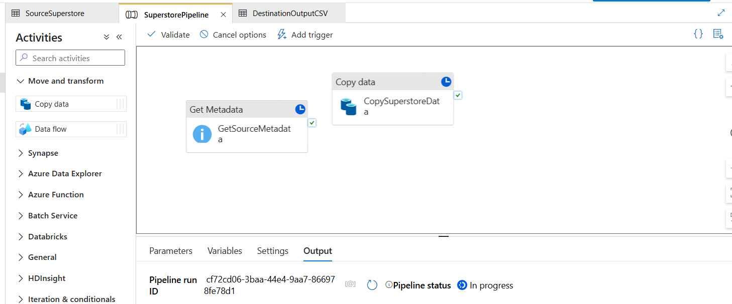

Screenshot showing pipeline execution (Succeeded)
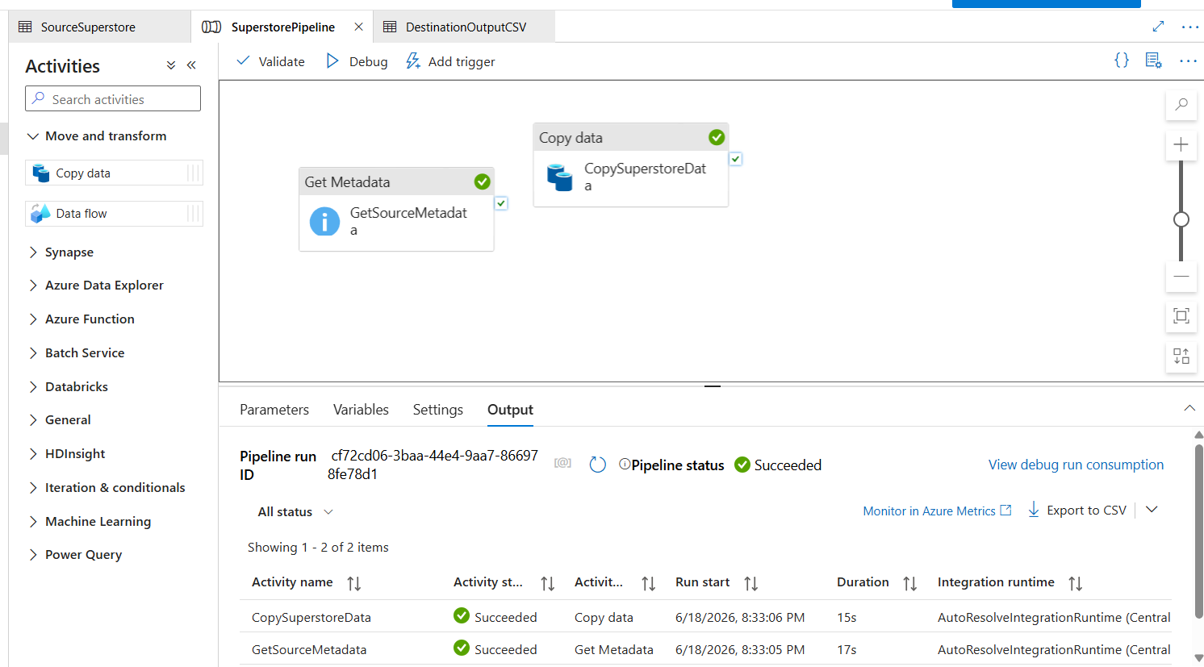

Verification of output:
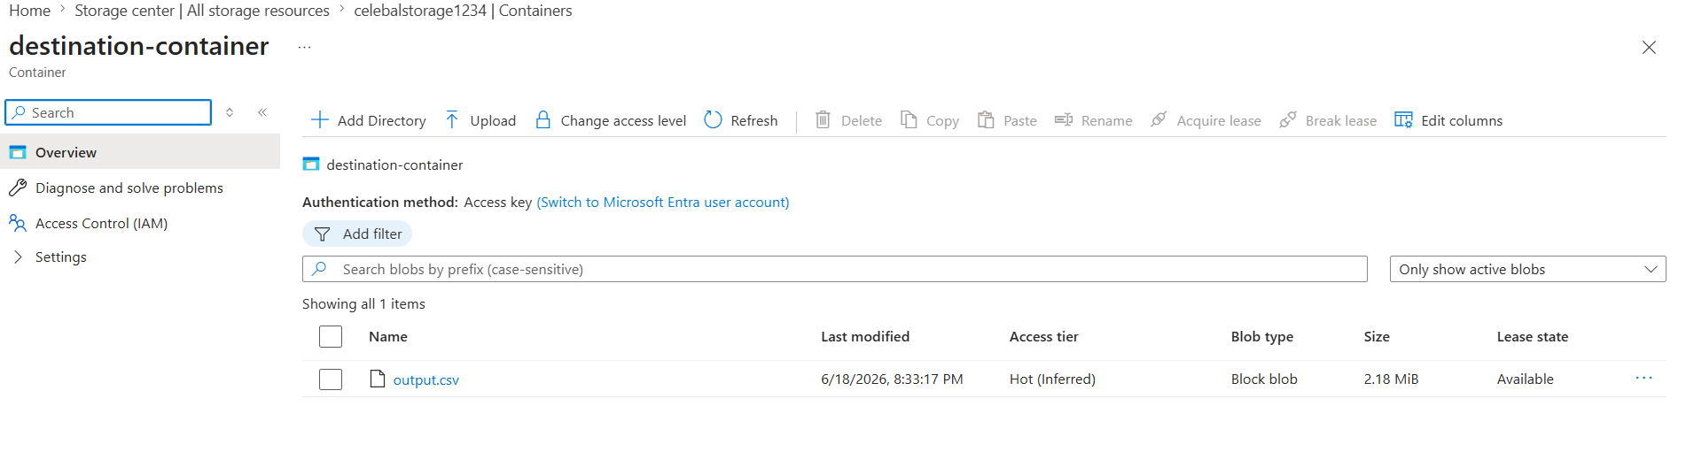
Task 6: IAM Roles
Do:
Assign oles:
- Reader
- Contributor
- Provide access to ADF for Storage
Deliverable:
Screenshot of role assignment

Steps Performed for Assigning Reader Role
- Opened the Resource Group celebal-adf-rg in the Azure Portal.
- Navigated to Access Control (IAM) from the left-side menu.
- Clicked + Add and selected Add role assignment.
- Searched for the Reader role and selected it.
- Clicked Next to proceed to the member selection page.
- Selected User, group, or service principal as the member type.
- Clicked + Select members and searched for my Azure account.
- Selected my account and clicked Select.
- Clicked Review + Assign and verified the role assignment details.
- Clicked Review + Assign again to complete the assignment.
- Verified that the Reader role was successfully assigned to my account.
- Captured a screenshot of the Role Assignments page showing the Reader role assignment.
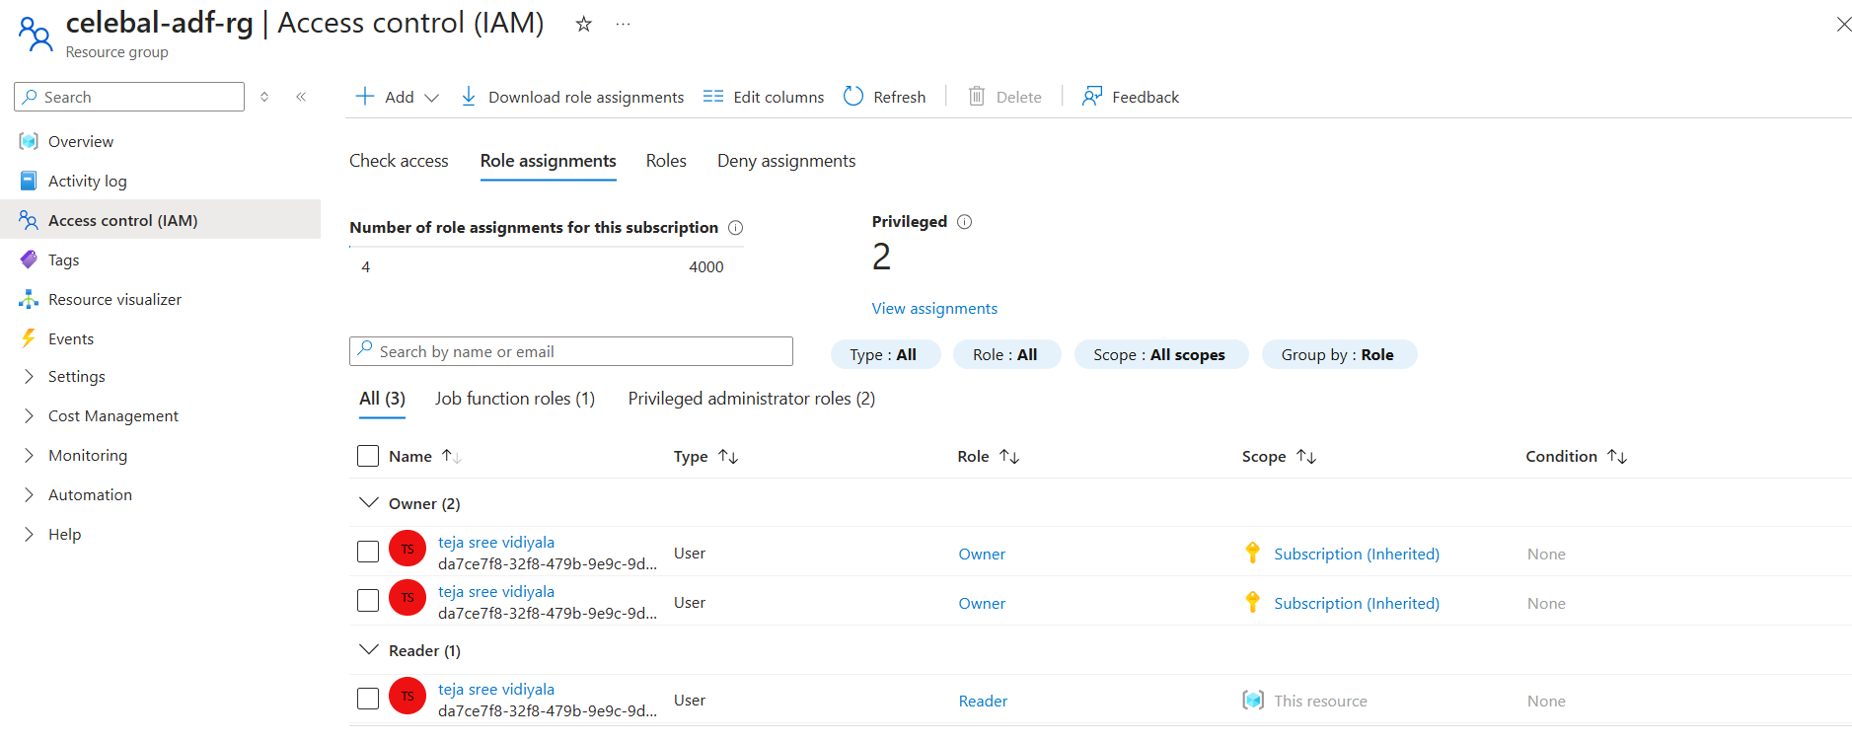

Steps Performed for Assigning Contributor Role
- Opened the Resource Group celebal-adf-rg in the Azure Portal.
- Navigated to Access Control (IAM) from the left-side menu.
- Clicked + Add and selected Add role assignment.
- Searched for the Contributor role in the role assignment list.
- Verified the available roles by searching under all role categories.
- Observed that the Contributor role was not visible in the available role list.
- Attempted to locate the role using different search and filter options.
- Concluded that the Contributor role was unavailable due to Azure subscription or permission limitations in the current environment.
- Captured a screenshot showing the Contributor role search results for documentation purposes
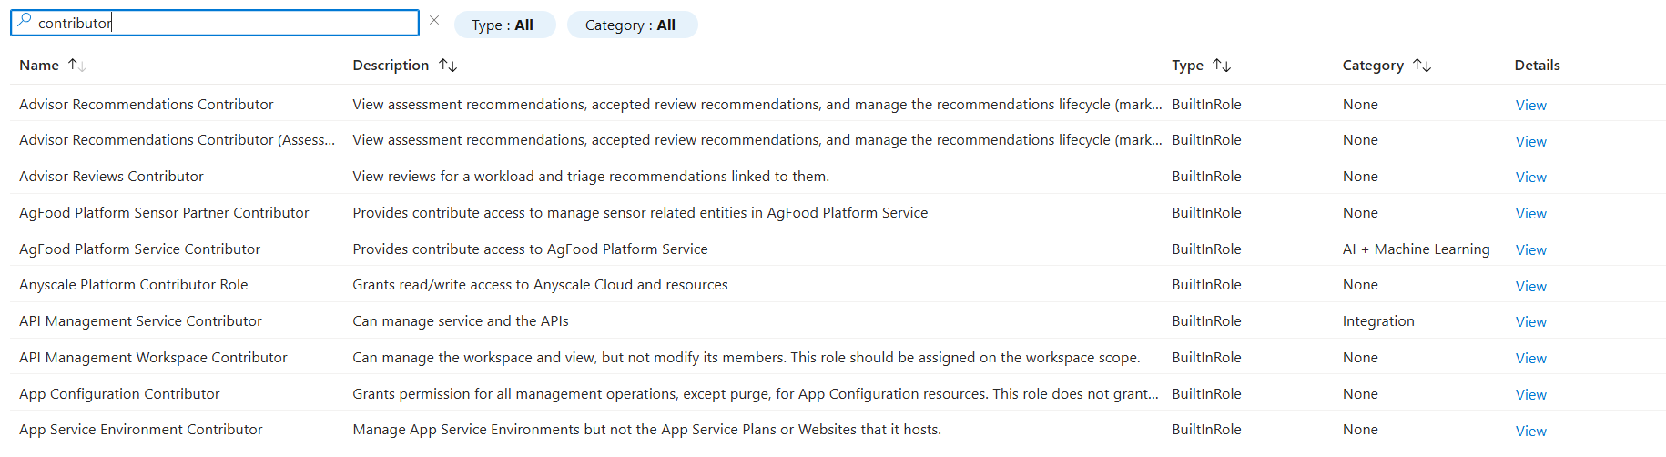

Steps Performed for Assigning Storage Blob Data Contributor Role
- Opened the Storage Account celebalstorage1234 in the Azure Portal.
- Navigated to Access Control (IAM) from the left-side menu.
- Clicked + Add and selected Add role assignment.
- Searched for the Storage Blob Data Contributor role and selected it.
- Clicked Next to proceed to member selection.
- Selected Managed Identity as the assign access type.
- Clicked + Select members and chose Data Factory as the managed identity type.
- Searched for the Azure Data Factory instance celebal-adf-teju and selected it.
- Clicked Select to add the managed identity.
- Clicked Review + Assign and verified the role assignment details.
- Clicked Review + Assign again to complete the assignment.
- Verified that the Storage Blob Data Contributor role was successfully assigned to the Azure Data Factory managed identity.
- Captured a screenshot of the Role Assignments page showing the Storage Blob Data Contributor role assigned to the Data Factory instance.
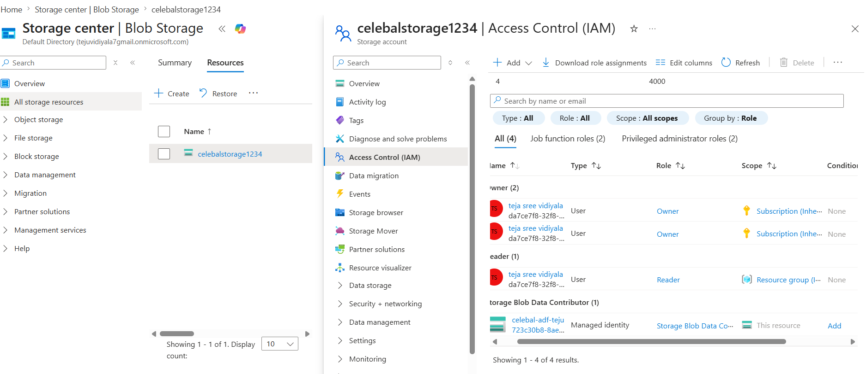

- 窗体底端

